1. Log into vCenter using web client (<https://119.0.203.63:9443/vsphere-client/>). Une INTAD credentials to log in.

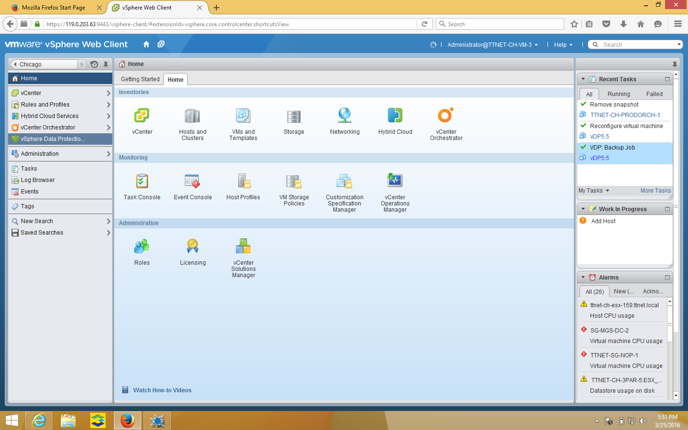

2. Click on “vSphere Data Protection” on left hand side. Click on “connect” to connect to VDP.

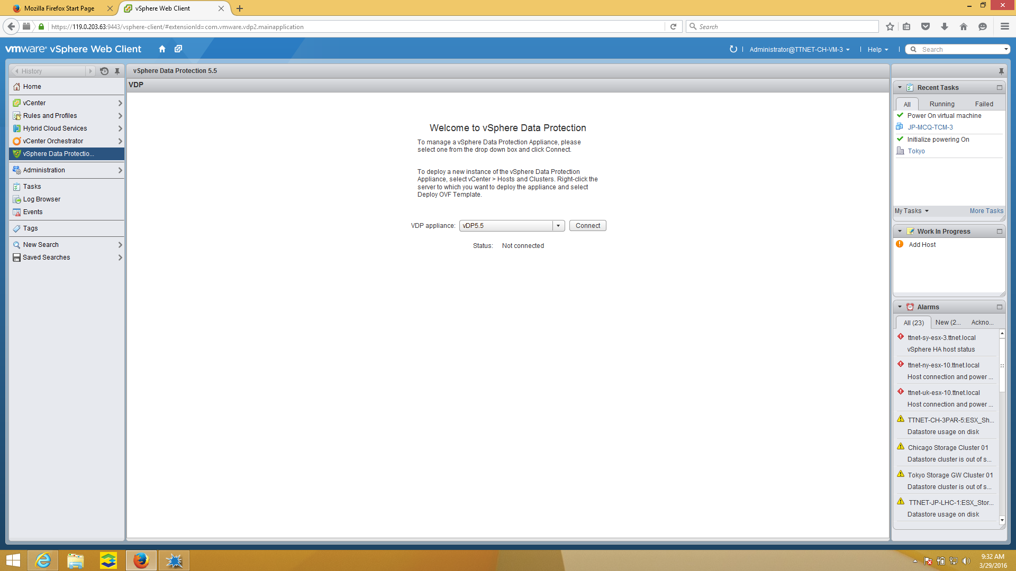

3. Click on the “Restore” tab. Click the arrow to the right of the VM name.

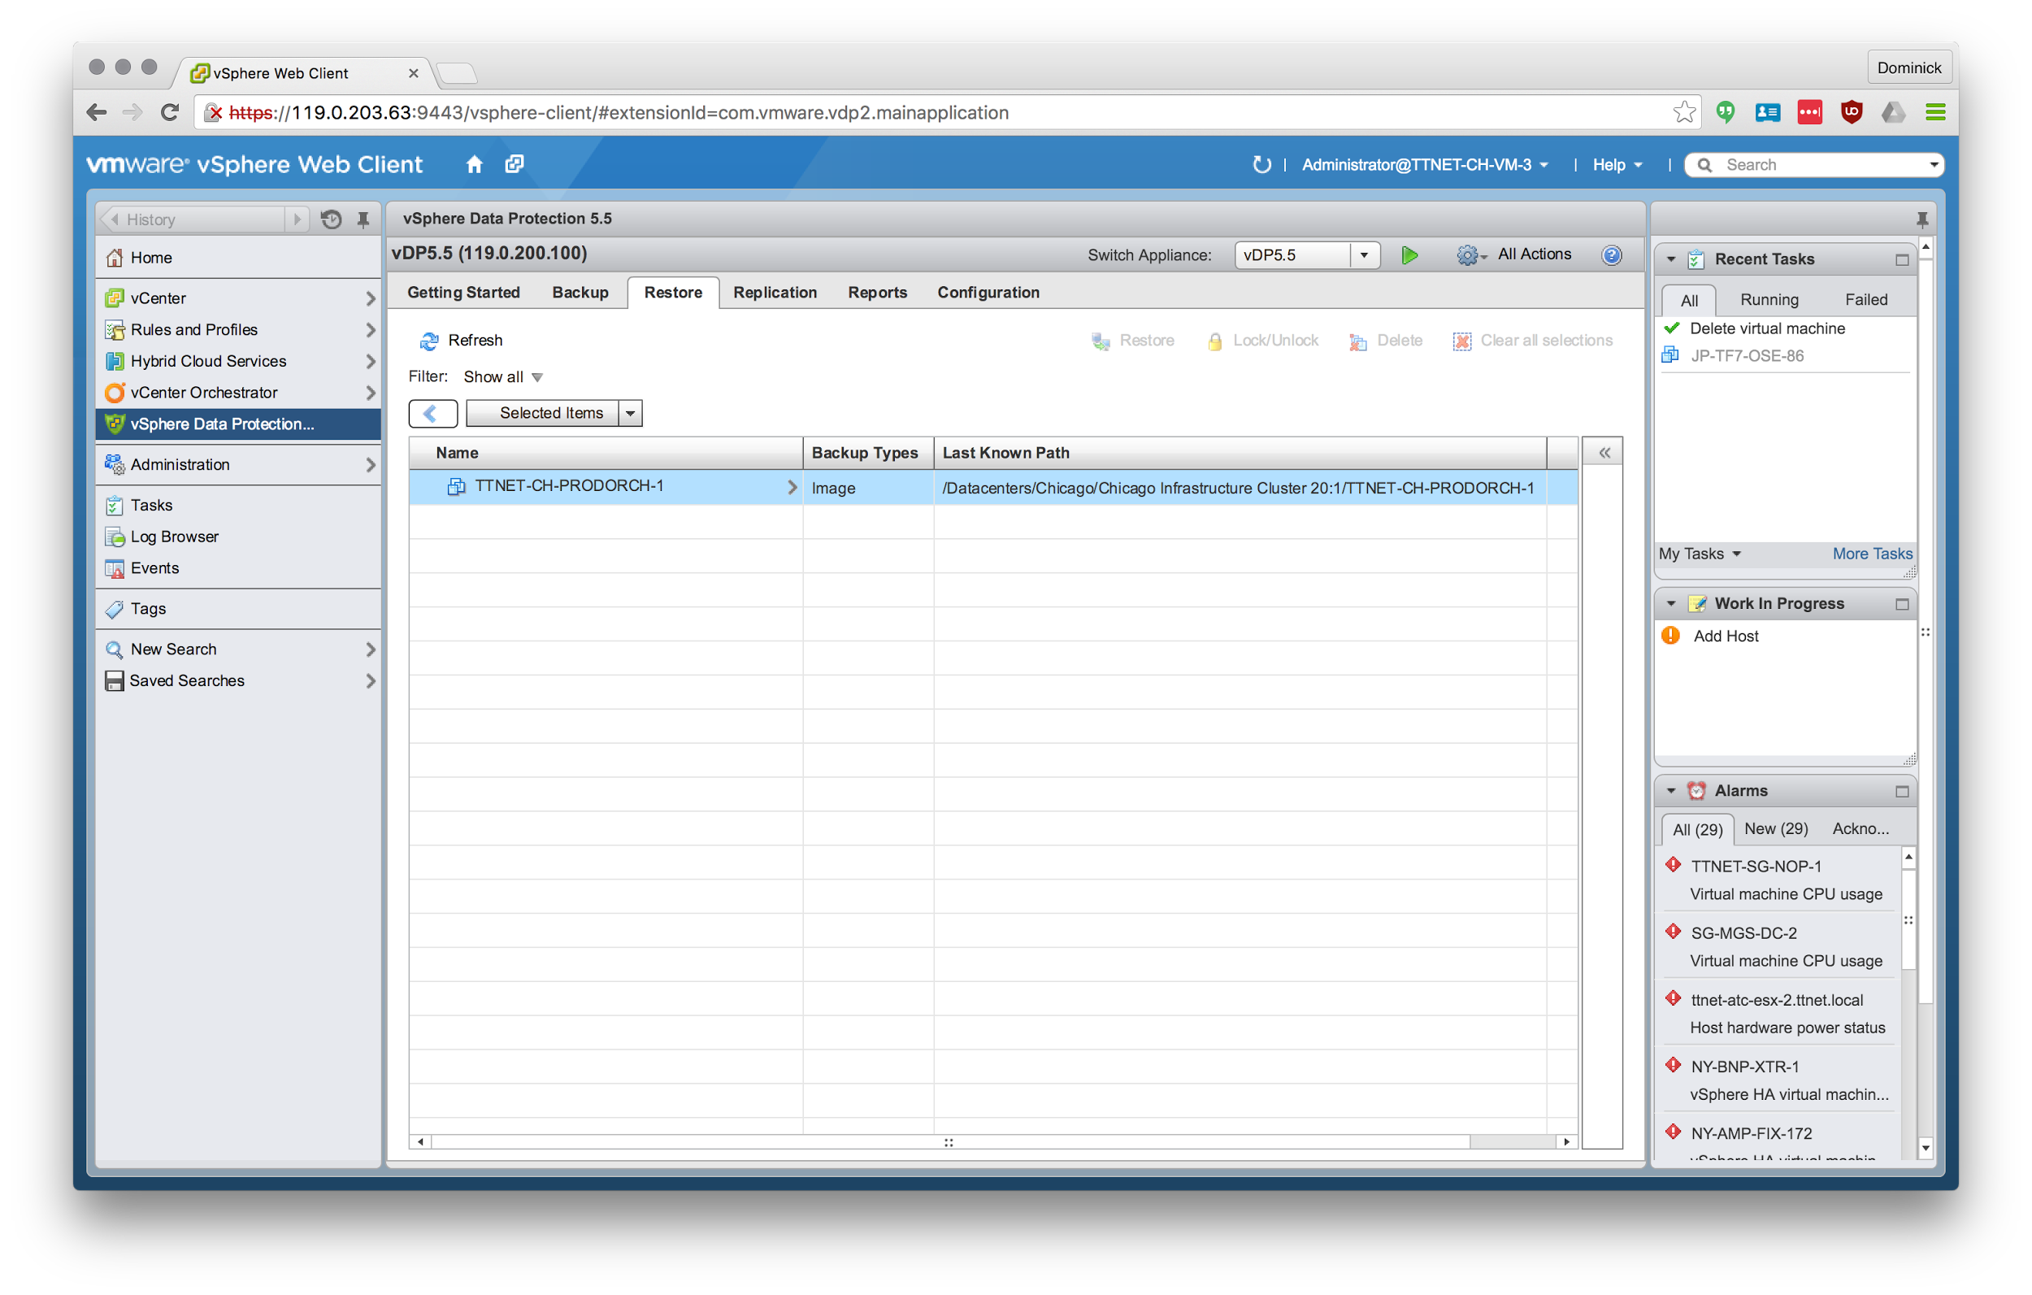

4. Select the backup to restore from and click “Restore” button on the top right.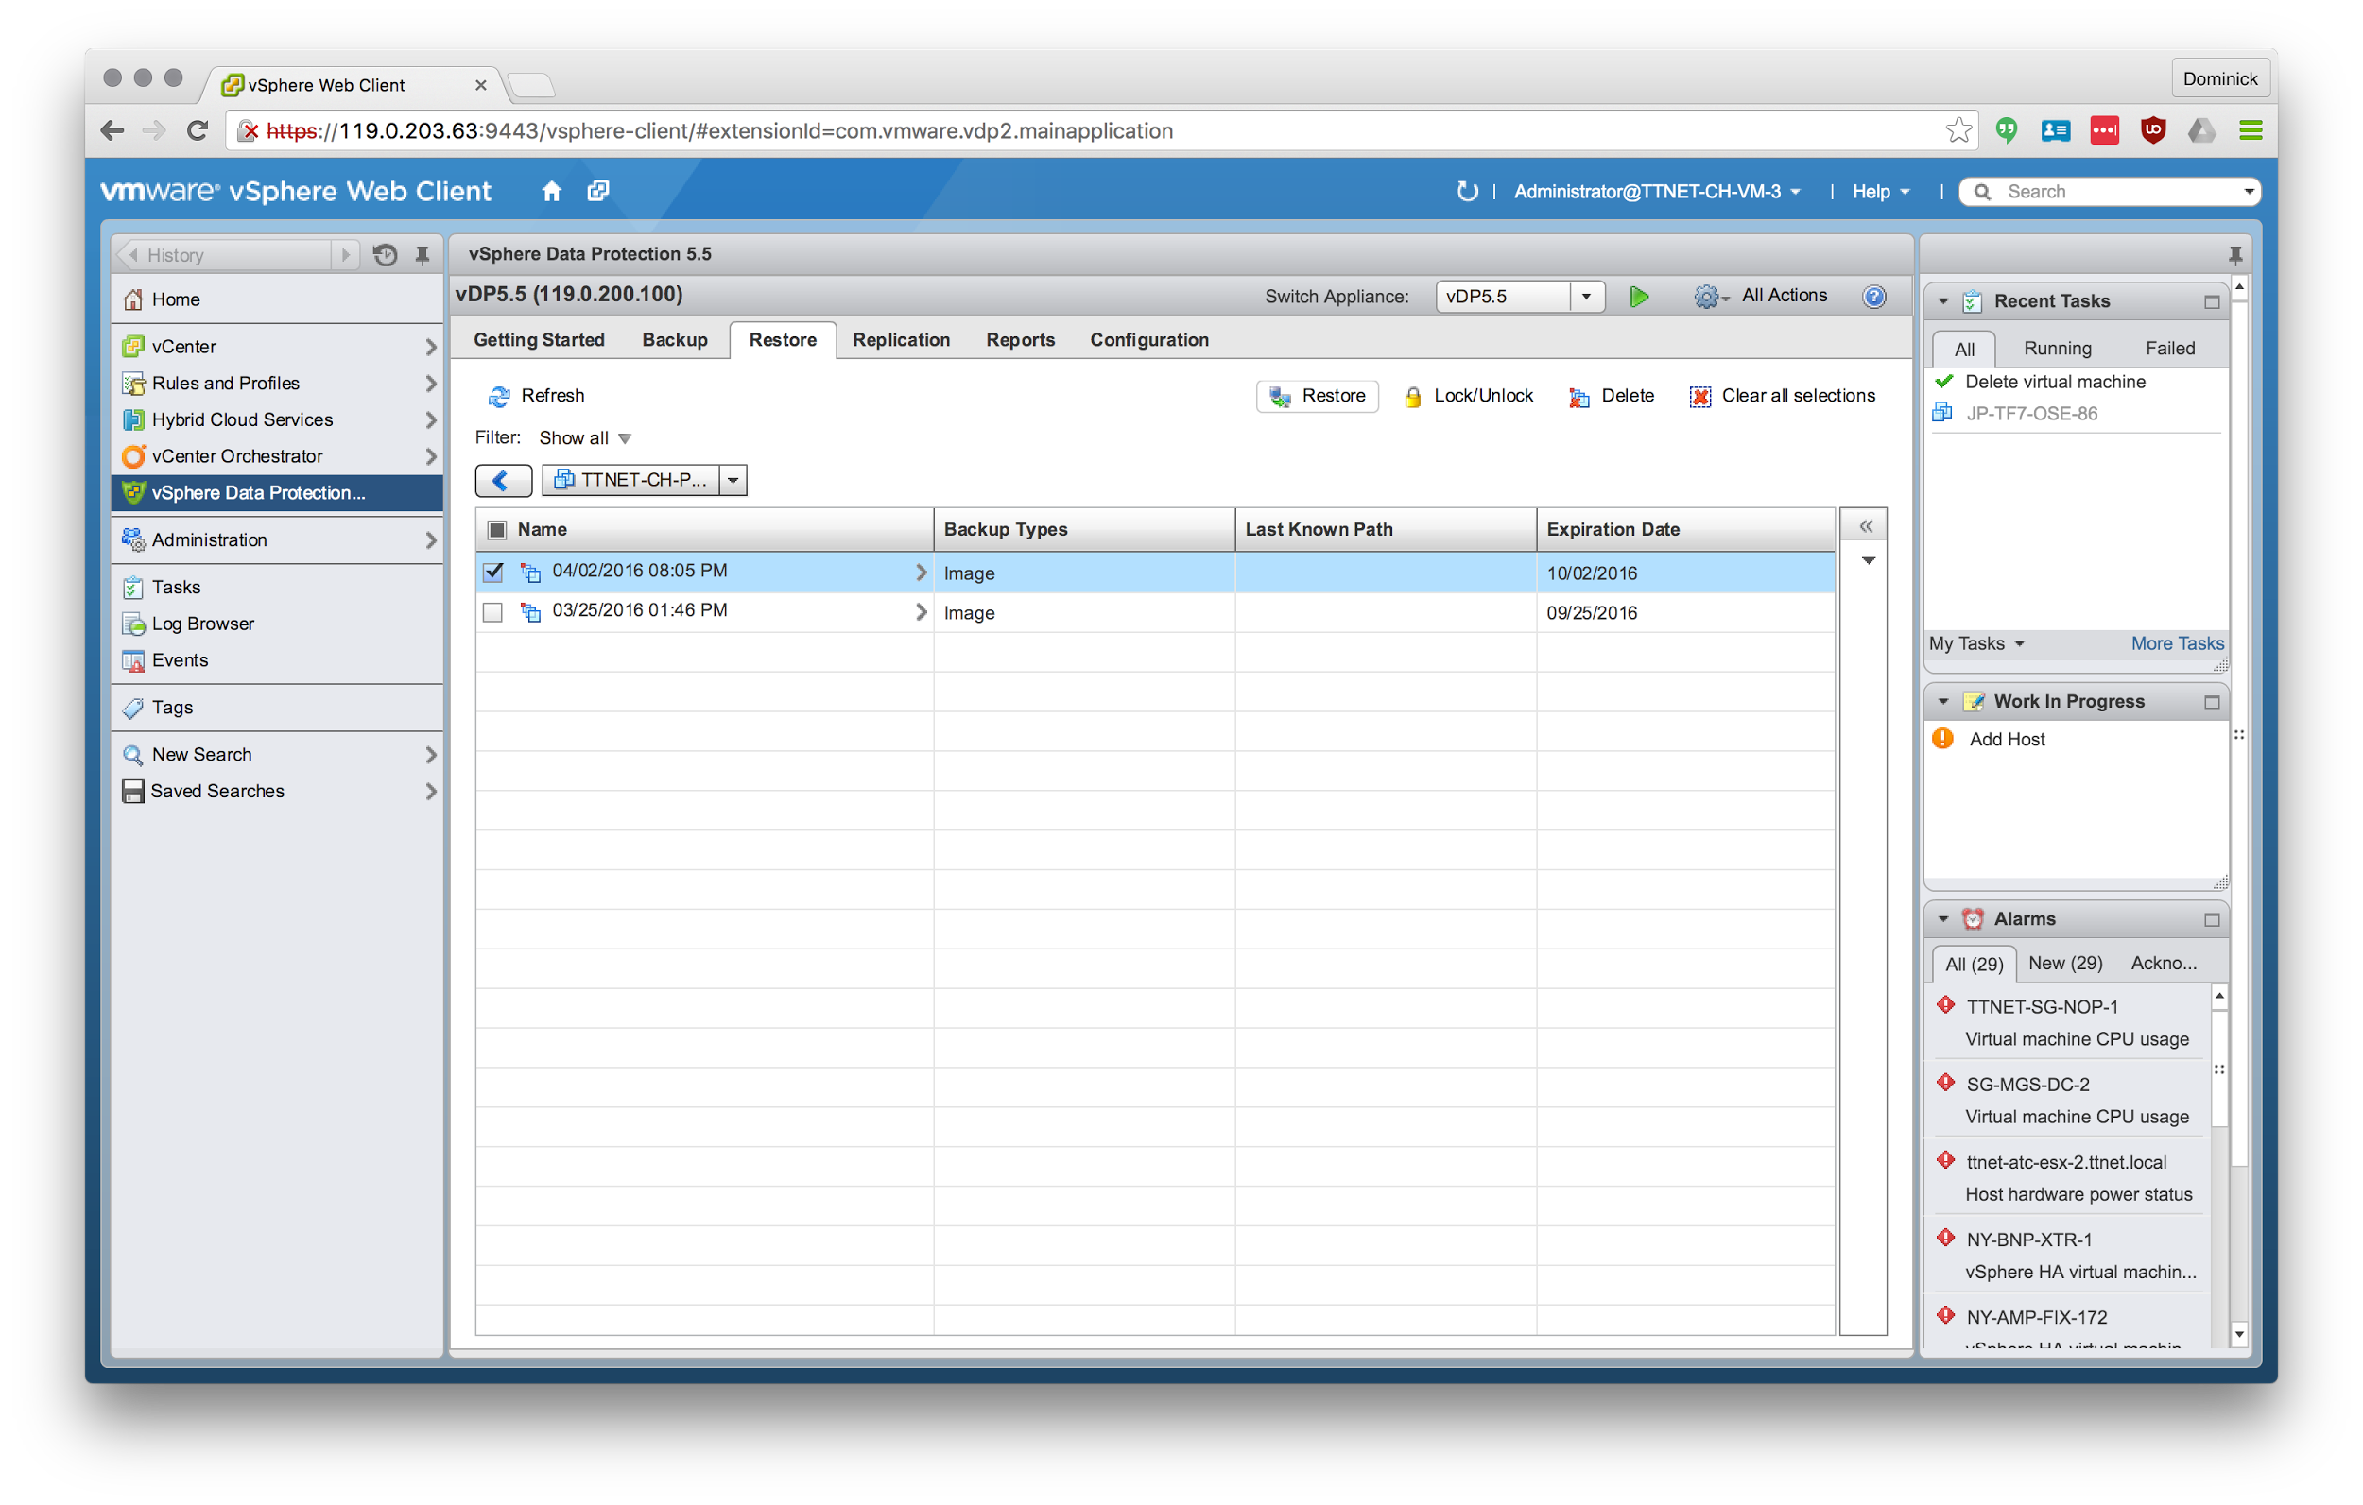

5. Click “Next”

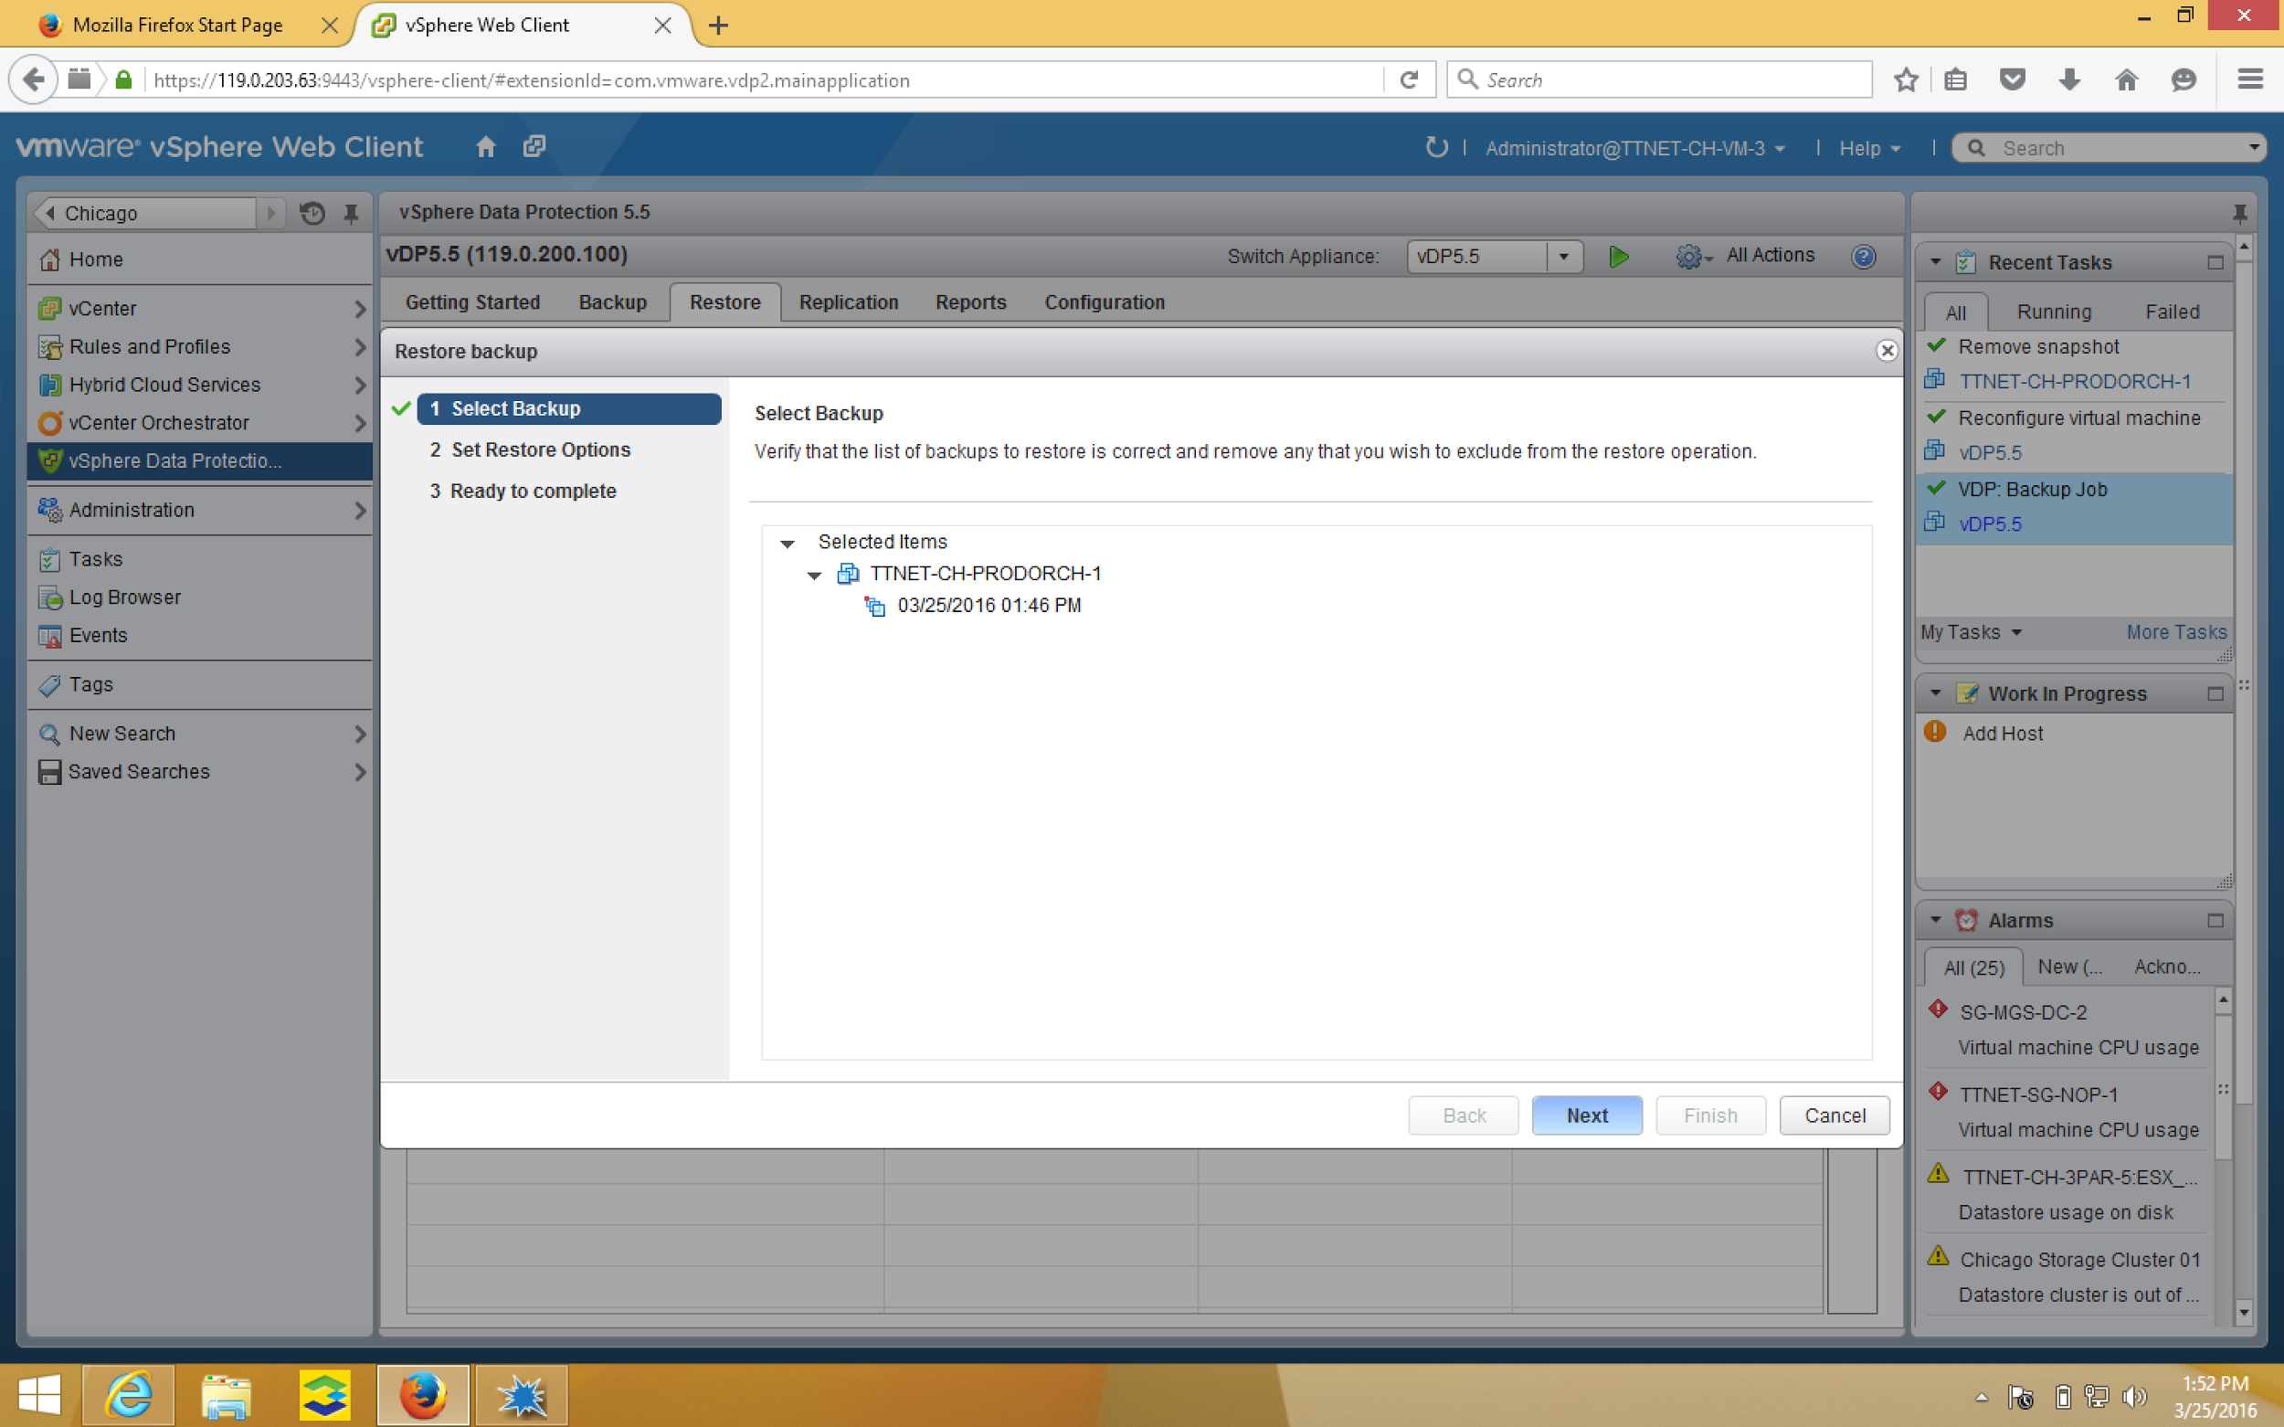

6. Check “Restore to original location”

7. Click “Finish” to begin restore process. 